CURRICULUM VITAE

PERSONAL INFORMATIONS
Full Name | NGUYEN BAO LOC
Profile picture | 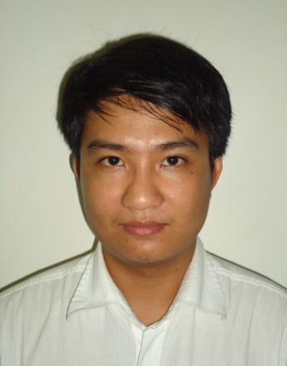
Address
  C4/23 Highway 1A, Tan Kien Ward, Binh Chanh District,
  Ho Chi Minh City
Experiences | 4 years | Cellphone | 098 554 6077
Email | nguyenbaoloc90@gmail.com | Date of Birth | 21/01/1990
Nationality | Viet Nam | Marital status | Single

EDUCATION
High school | Mạc Đỉnh Chi
 | Sai Gon Technology University  Major: Computer Science
  Bachelor’s Degree

CAREER GOALS
- LONG-TERM:
  - Participate in the formulation and development of a leading company.
- MEDIUM AND SHORT-TERM:
  - Becoming qualified to become a good programmer and is pivotal in the company.

WORKING TIME
Work Type | Position and Company Name | Work Job
Full-time  (04/2014 – now) | Team Leader  (Rasia Viet Nam Ltd. Co)
Full-time  (10/2013 – 03/2014) | Junior Developer  (Ngoc Tung JSC) | Participate in company software; using DevExpress 7.1, C #. Net and SQL Server 2005.  Management and maintenance of software in use.
Out Sources  (7 months) | Developer  (T.H.M.S Products & Trade Ltd. Co) | Participate in accounting software for company; 12.2.7 using DevExpress , C #. Net and SQL 2008 R2.
Out Sources  (5 days) | Developer  (Vinh Nam Packaging Join Stock Company) | Built a website with Joomla 2.5 for company
Full-time  (04/2012 – 09/2013) | ERP Developer  (Green Sun Software Solution Corporation - Asoft) | Outsources, Researches, C#.Net, ASP.Net MVC 4 and projects of ERP implementation
Out Sources  (4 months) | Develop management applications Thanh Phuc petrol outlets | Analyse, develop application based on C# and DevExpress tool.
Out Sources  (14 days) | Develop management applications gym in District 4 | Analyse, develop application based on C# and DotnetBar tool.
Part-time | Software Division in Phuoc Lap Mobile | Root and update firmware on mobile

SOFT SKILLS
Languages | English (University Level)
Computer Skills | Basic skills (repair computer, MS Word, Excel, Powerpoint…) and other advanced skills (web design,program…)
Strengths | Passion in Programming.  Attention to detail and dedication to work.  Good ability to use the Internet to solve problems and high seft-learning.
Other Skills | Team – work skills.  Communications skills.  Problem – solving skills.  Organizational skills.  Have a sense of responsibility.

PROGRAMMING
Languages | Ranks
C# .Net, ASP.Net | Good
Java, PHP | Rather
CFML, JavaScript | Good
EXTRA CURRICULAR ACTIVITIES
- Join admissions consulting room for training Saigon Technology University.
- Winner of the second place and the champion CUP soccer IT-STU over the years 2008 and 2012.
- Winner of the second place team prize presentation "Vaio-Connect for my vision" by SONY organizations.
- Teach the children who are in difficult circumstances and no condition to go to school at the place of living.
- Participate in blood donation in University and a number of charitable activities.

HOBBIES AND INTERESTS
- Programming, Movies, Travellings…
- Play games: Need For Speed, Dota, PES...
- Play sports games: football, basketball, voleyball…
- Have a passion for electronic devices such as cellphones, tablets, laptop…

